Practical No. 4
Aim : 5) WAP to check if a number is Positive, Negative or Zero.

Name : Danish Altaf Solkar | Class : CO - B
Enrolment no. : 24111590805 | Batch : 2

Code :-
num=float(input("Enter a number : "))
if num>0:
print("Number is Positive")
elif num<0:
print("Number is Negative")
else:
print("Number is Zero")

OUTPUT :-
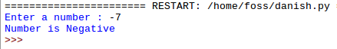

Process related  (30) | Product related  (20) | Total Marks  (50) | Signature

